In this lab

* We will group multiple tasks into one.
* Then we will make them execute in transaction.

Step 1: Prepare Database

Create a database called ContainerDemo and a table called Customer as follows in the SQL Server

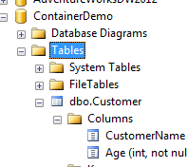

### Step 2: Create Integration services project

Create new SSIS project using SQL Server Data tools.

Step 3: Add Connection Managers

Add Ado.net Connection manager and connect it to ContainerDemo database

Step 4: Add Container

Add sequence container in control flow.

Step 5: Add Execute SQL Task

1. Create three “Execute SQL Task” inside sequence container.
2. Set ConnectionType as ADO.NET for all three of them.
3. Set connection to one created in step no 3 for all three of them.
4. Set SQLSourceType to DirectInput for all three of them.
5. Set SqlStatement to
   1. insert into Customer values('A',55) for first task
   2. insert into Customer values('B',60) for second one
   3. insert into Customer values('C',’CC’) for third one

**Note:**

* Third query will leads to error because Age is integer and we are passing string.
* Don’t connect three tasks inside sequence container using precedence constraints. Let them execute in parallel.

Step 6: Execute and Test

Press F5 and Test the application.

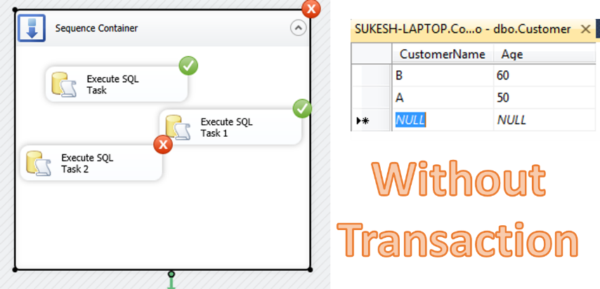

Step 7: Enable Transaction

1. Right click Sequence container and select properties
2. In the property window set value of TransactionOption property to “Required”

Step 8: Execute and Test

Press F5 and test the application

**Note:** Make sure to delete all the exiting records from the table before you execute so that you get a clear picture of record insertion without any confusion.

